CSA0998-PROGRAMMING IN JAVA

DAY-4

ASSIGNMENT

Name:K.Koushiknath Reddy

Reg.no:192110156

Dept:CSE

1.**PROGRAM:**

import java.util.Scanner;

public class CharacterCount {

public static void main(String[] args) {

Scanner scanner = new Scanner(System.in);

int uppercaseCount = 0;

int lowercaseCount = 0;

int numberCount = 0;

System.out.println("Enter * to exit...");

char inputChar;

do {

System.out.print("Enter any character: ");

inputChar = scanner.next().charAt(0);

if (Character.isUpperCase(inputChar)) {

uppercaseCount++;

} else if (Character.isLowerCase(inputChar)) {

lowercaseCount++;

} else if (Character.isDigit(inputChar)) {

numberCount++;

}

} while (inputChar != '*');

System.out.println("Total count of lower case: " + lowercaseCount);

System.out.println("Total count of upper case: " + uppercaseCount);

System.out.println("Total count of numbers: " + numberCount);

scanner.close();

}

}

Output:

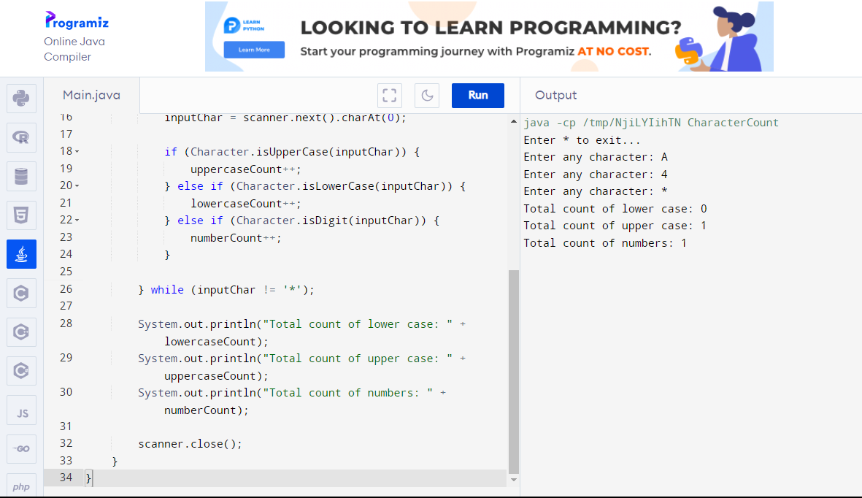

2.**Program:**

class Superclass {

int value;

Superclass(int value) {

this.value = value;

}

void display() {

System.out.println("Superclass value: " + value);

}

}

class Subclass extends Superclass {

int value;

Subclass(int superValue, int subValue) {

super(superValue);

this.value = subValue;

}

void display() {

super.display();

System.out.println("Subclass value: " + value);

}

}

class Main {

public static void main(String[] args) {

Subclass obj1 = new Subclass(10, 20);

obj1.display();

Subclass obj2 = new Subclass(-20, -30);

obj2.display();

Subclass obj3 = new Subclass(0, 0);

obj3.display();

}

}

Output:

